RBR Pacenote Plugin

Quickstart

Table of Contents
Introduction 2
Usage 2
Pacenote Editor 2

Introduction
As in real life at first some theory before we take a look at how to use and customize the plugin. Corner calls are the most important pacenotes when it comes to rally driving. To take this into account we have slightly improved the way corners, or more precisely, corner angles are mapped to pacenote calls.

The following table depicts how the plugin maps the extended, numeric corner calls to the original calls used in vanilla RBR:

Slot | Rbr | Plugin | Synonym | Angle (°) | Range (°)
1a | HAIRPIN | 1 | HAIRPIN | 180..150 | 30
1b | HAIRPIN | 2 (new) |  | 150..105 | 45
2 | 90 | SQUARE | JUNCTION | 105..75 | 30
3 | K | 3 |  | 75..60 | 15
4 | MEDIUM | 4 |  | 60..45 | 15
5 | FAST | 5 |  | 45..30 | 15
6 | EASY | 6 |  | 30..15 | 15
7 | FLAT | FLAT |  | 15..5 | 10

The most important change is the plugin's corner pacenote „2“, which has been inserted between RBR's HAIRPIN (plugin: „1“) and „90“ (plugin: „SQUARE“) calls.
This should be compatible with the original RBR pacenote handling, as most, if not all, corners having an angle less than 90 degrees were called as hairpins anyway in most of the tracks.
So, if you use pacenotes edited with the plugin's pacenote editor in a standard RBR installation without plugin, the „2“ corners would be called out as hairpins.

Usage
In the following sections we will describe how to use the plugin's pacenote editor and some other useful features as well.

Pacenote Editor
To use the Pacenote Editor you have two options: while driving a stage or while watching a replay. So here we go. As a first example we will use the Rally School stage because anyone knows it and it's short and simple.Start RBR and at first take a look at the „Options-->Pacenotes“ settings, which should look something like this:

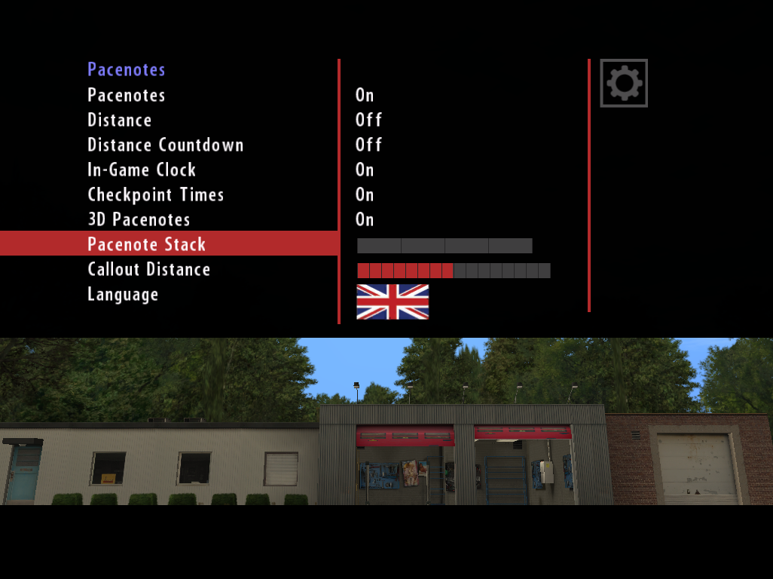
We will use these settings during this guide. Most of these options can be changed directly in the plugin's „Pacenote List“ dialog.
The bottom three settings have to be set here:
- Pacenote Stack
The number of pacenote icons shown on the right edge of the screen.
- Callout Distance
This is the most important one and specifies the time in seconds a pacenote gets called in advance when approaching the actual location of the pacenote. Each highlighted square increases the value by 0.5 seconds. The default value is 8 squares which results in a callout distance of 4 seconds. So the faster you drive, the earlier the call happens.
- Language
This comes into play when you use the original calls instead of the ones supplied by the plugin.

Launch the Rally School stage using vanilla RBR or your favorite plugin and notice that you will see … nothing unusual. That's how it is supposed to work. Pacenote Plugin is a guest in the RBR environment and behaves as such.
To activate the Pacenote Editor simply double-click the LEFT mouse button, although usually you do not see a mouse pointer, but that doesn't matter.
After left double-clicking the left mouse button you should see something like this, the „Pacenote List“ dialog:
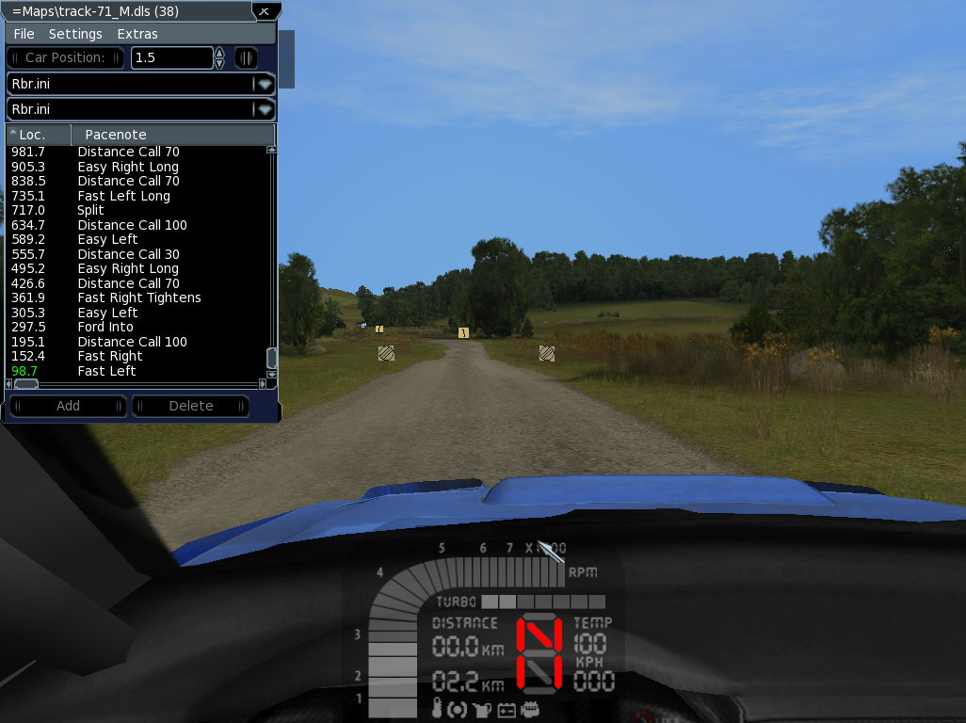
Notice that you have a grey mouse pointer now, to use the plugins interface.

From top to bottom you have:
- Dialog title
Showing the name of the current DLS (pacenote) file being loaded by RBR and the number of pacenote calls contained. The „=“ sign indicates that the pacenotes have not been changed yet.
- Menu bar
The menu bar contains various menu items for saving, changing settings an some screen related options.
- Car Position
The car position button initiates a jump to the location specified in the spinner control next to it. The small button on the right edge toggles the playing of the replay if appropriate.
- Add and Delete
These buttons allow you to add or delete a pacenote to or from the list, respectively.
- Pacenotes and Ranges INI files
The two comboboxes specify the pacenote definition files (INI files) currently being in use to edit pacenotes and distance calls, respectively.
- Pacenotes List
The most important part of the dialog lists the pacenotes of the stage in location order. Sorted from bottom to top it appears like a pacenote sheet co-drivers use in real life.

We leave the default pacenote definitions „Rbr.ini“ for both unchanged now, more details on that topic in the manual.
Let us change some notes to see how it works. Drive a few meters into the stage and select the pacenote you want to change in the list, we use the first two corners to add a „cut“ call:

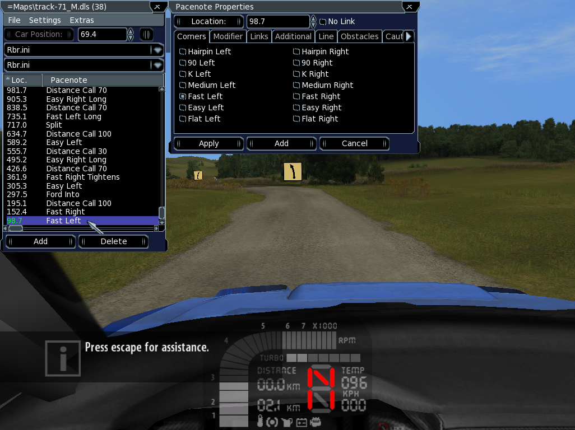
Notice that a new dialog „Pacenote Properties“ is shown to the right of the list dialog. This „Pacenote Properties“ dialog is used to edit an already existing or added pacenote.
Pacenotes are grouped into categories to ease finding and choosing an appropriate one.

The first, recommended step is to resize the window to suite your needs by grabbing the bottom right corner of the window and dragging the edge with the mouse, like this:
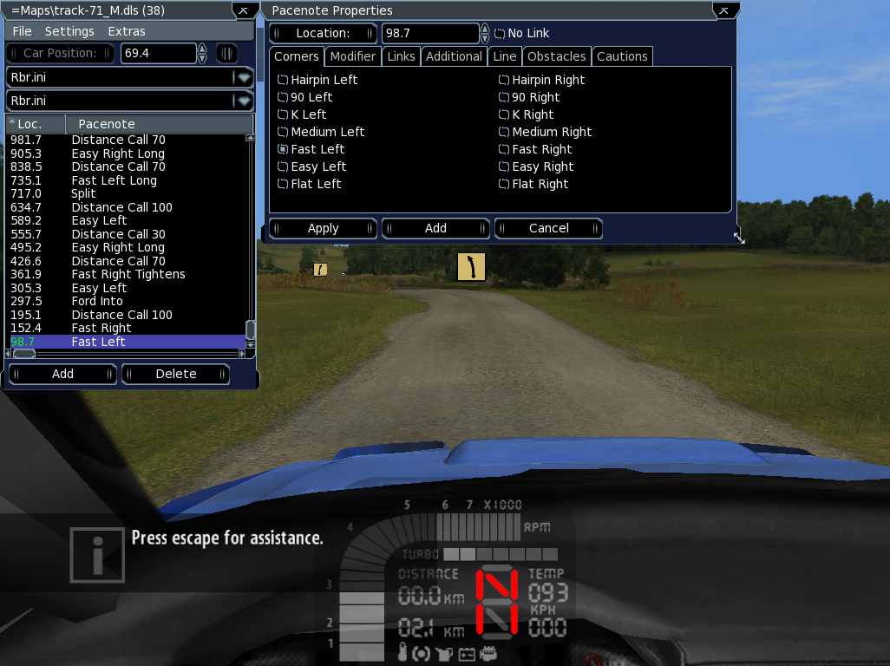
To store a window position permanently, close it with the close button («X») in the upper right corner. The next time you start RBR and the editor, the window position gets restored.

Now select the „Modifier“ tab and check the „Cut“ checkbox for the first corner:
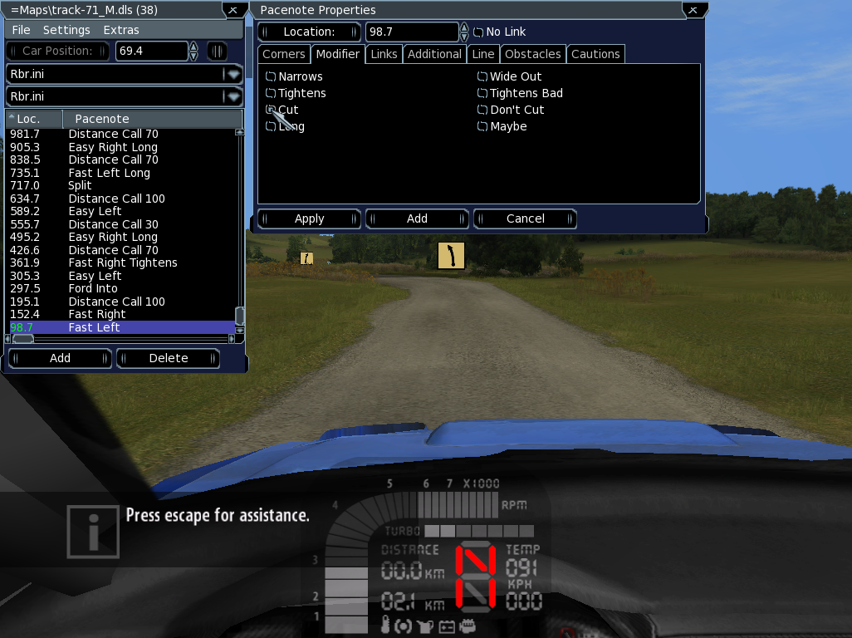
You have to click the „Apply“ button to apply the changes made to a pacenote. This updates the pacenotes list window:
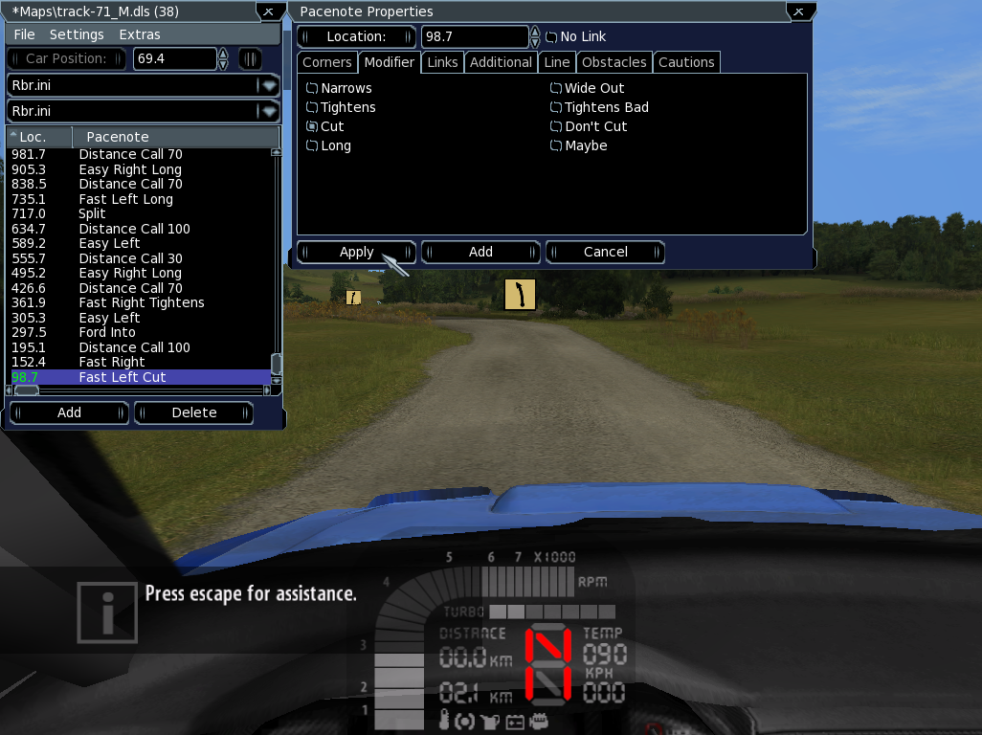
Notice that the window title of the list window has a «*» as prefix, which indicates that a change has been made to the list.
Select the next „Fast Right“ corner and repeat the previous steps, so you end up like this:
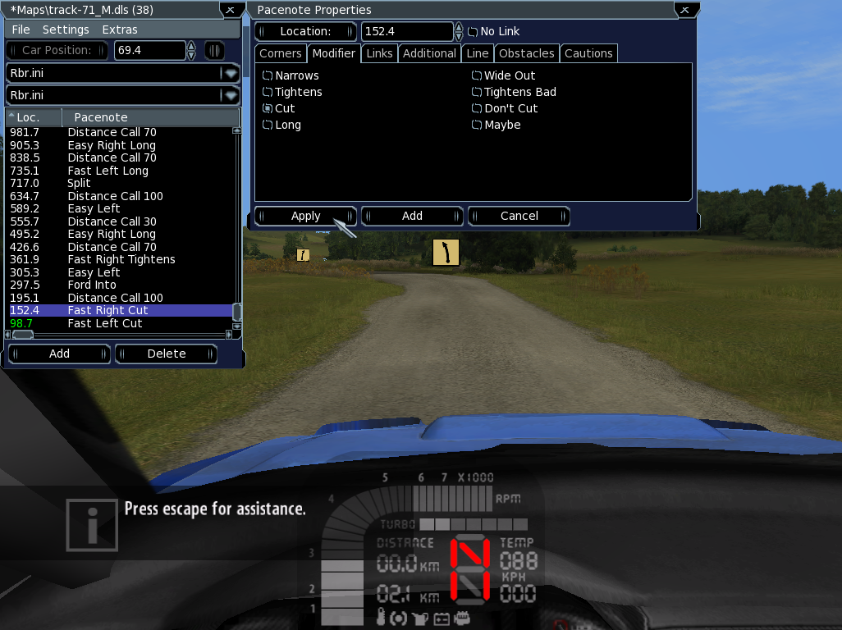
Drive through the corners and notice that the added „Cut“ modifiers are called as expected. No need to reload the stage or save the notes to a file, yet.

From memory you know that when driving through the first water ford, the car jumps and loses grip at the rear tyres. From the list window you see the ford is around 290 meters into the stage, so let's get there as quick as possible.

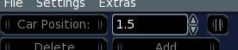
Use the up and down buttons of the spinner control located in the pacenote list window and set the value to around 290, notice that after adjusting the value, the „Car Position“ button gets enabled:

Hitting the „Car Position“ directly gets you to the desired location on stage.
As this is not exactly the location where we want to place the new pacenote, we drive a few meters to position the car right where we would like a new „Caution“ pacenote to be placed.

Press the „Add“ button to add a note and notice that the „Location“ of the note has a value of „152.5“ and is a „Hairpin Left“ corner. By default, new notes get the location of the previously selected note plus a small gap.

To set the location of the note to the current car position, press the „Location:“ button in the properties window.

Navigate to the „Cautions“ tab, select the „Caution“ checkbox and hit „Apply“:

If you are not satisfied with the position, adjust it by setting the value in the spinner next to the „Location:“ button. Don't forget to „Apply“.

When you are satisfied with editing the pacenotes you may save them to the pacenotes (DLS) file via the menu item „File-->Save“:

Notice the message after saving and the changed window title:

When saving a DLS file the first time, a backup copy of the original file is placed into the „backup“ subfolder underneath the plugin's folder.

Important:
You have to save the pacenotes before leaving the stage, otherwise all changes made are not saved permanently and will be lost. You have been warned!

Camera Editor
To activate the Camera Editor window, double-click the RIGHT mouse button. The Camera Editor dialog will only be visible if the current RBR camera mode is one of the internal cameras „cam_bonnet“, „cam_bonnet2“ or „cam_internal“. All other cameras (external, replay) are not editable hence the dialog is not shown.
The dialog has two tabs. The first enables you to change the camera, the second allows for changing the positions of the minidash and the digidash (=full dash), respectively.
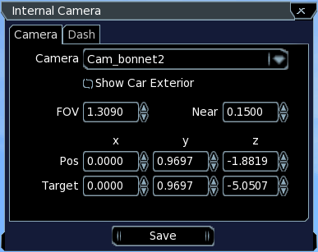
You can change the current camera by choosing an entry in the „Camera“ combo box. To edit the geometry values you use the up/down arrows of the spinner controls or enter a value directly. The values represent the corresponding keys in the camera ini file.
Click the „Save“ button to make the changes permanent. The values of the car specific camera settings are being saved to the ini file of the current car. The custom camera geometry values are being saved to the „Cameras.ini“ file located in the Pacenote Plugins folder.
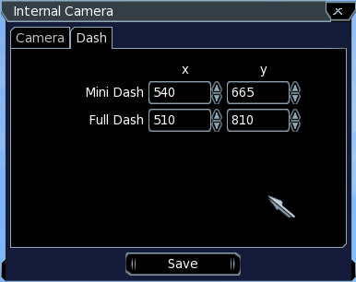
The „Dash“ tab lets you change the position of both dashes. The „Save“ button saves the positions to a separate ini file located in the Pacenote Plugins folder. The positions are restored if you restart RBR.

Car Damage Indicator
The Car Damage Indicator window can be activated by selecting the corresponding menu item in the „Extras“ menu of the Pacenote List dialog.
The Car Damage window shows the damaged parts in alphabetical order along with the damage suffered. Click on the column header to sort by that column.
